Tutorial 1

1. Rstudio installation

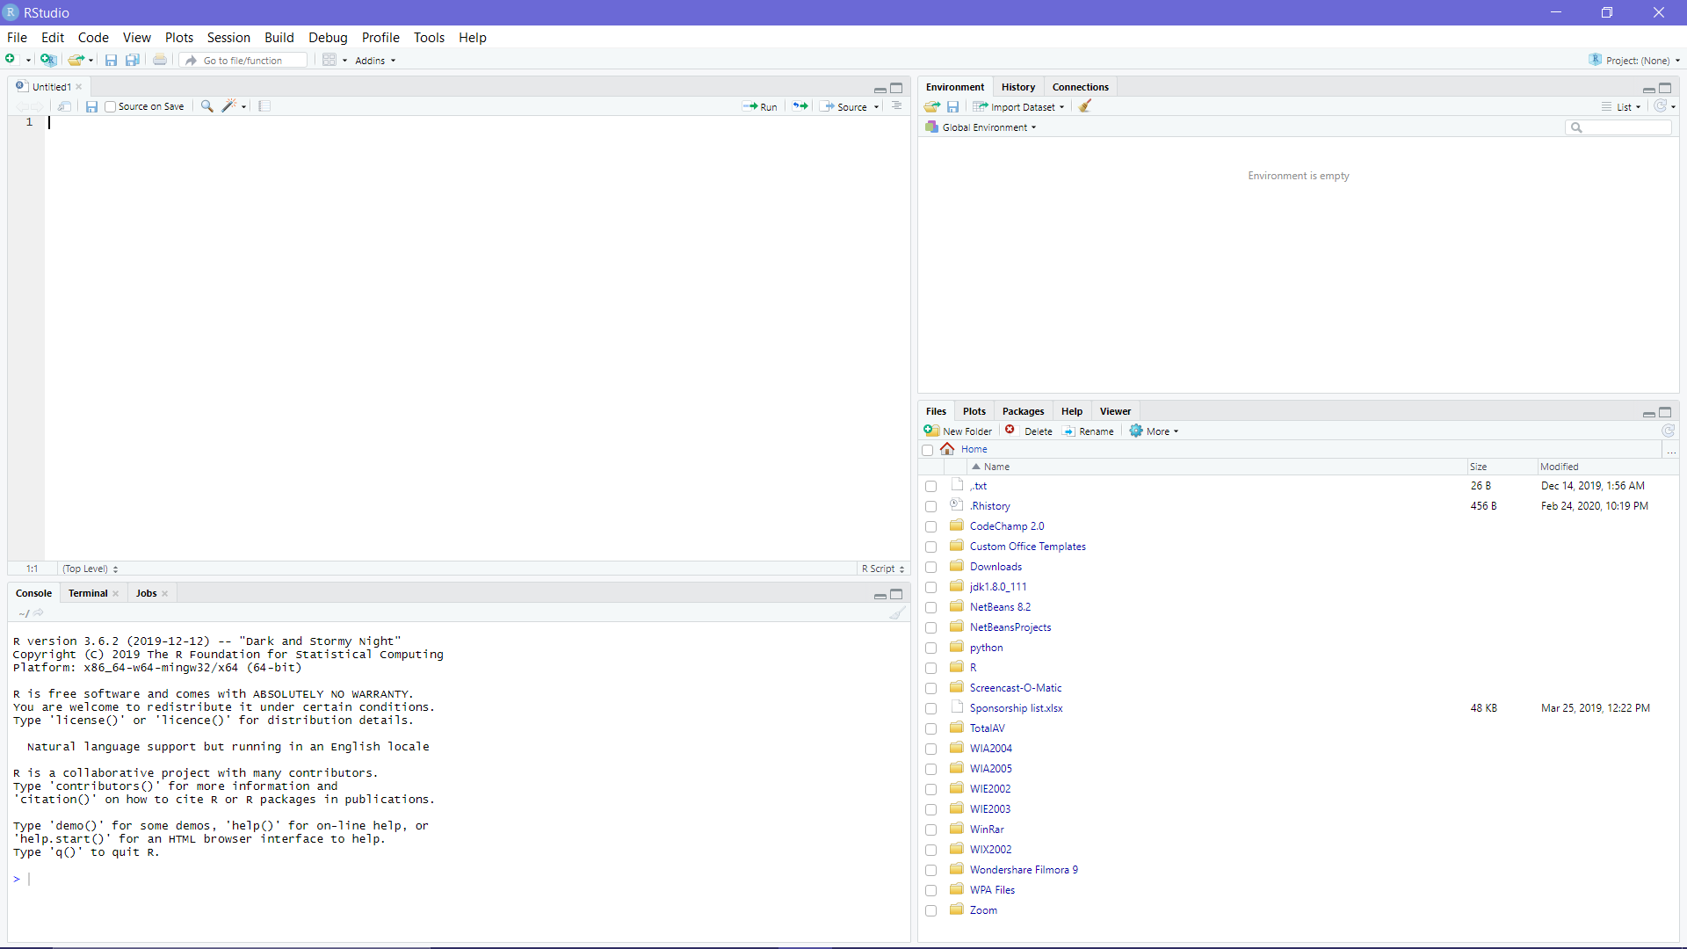

2. GitHub link of repo : <https://github.com/ikasyahmi/introdatascience>

3. GitHub HelloWorld link: <https://github.com/ikasyahmi/introdatascience/blob/master/HelloWorld.md>

4. Screenshot of my gitHub

